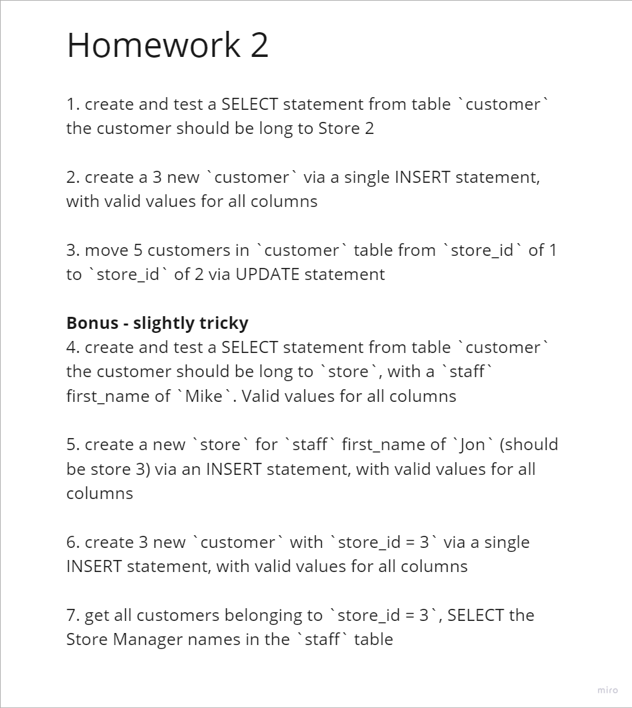

1.

SELECT *

FROM customer

WHERE store_id = 2

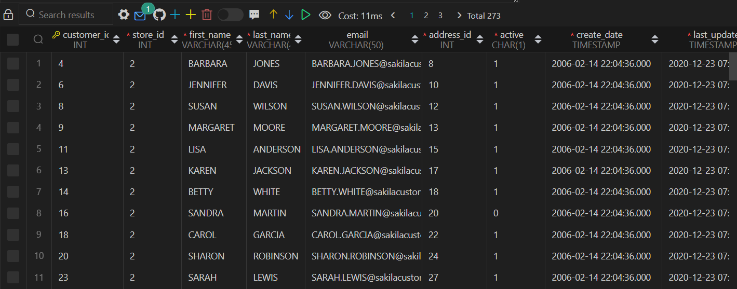

2.

INSERT INTO customer (customer_id, store_id, first_name, last_name, email, address_id, active, create_date, last_update)

VALUES

(600, 2, 'Christian', 'Brown', '@nyemail', 600, 1, TIME(), TIME()),

(601, 2, 'Jimi', 'Hendrix','@nyemail', 601, 1, TIME(), TIME()),

(602, 2, 'James', 'Morrison', '@nyemail', 600, 1, TIME(), TIME());

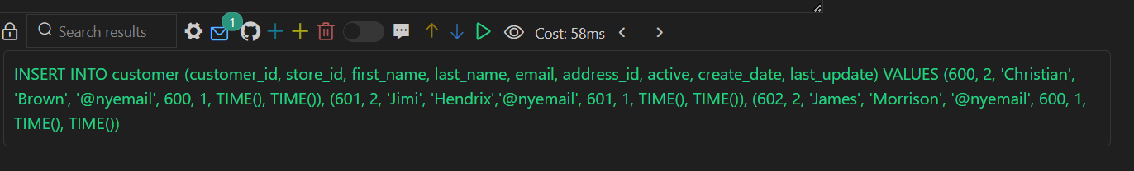

3.

UPDATE customer

SET store_id = 2

WHERE store_id = 1

AND customer_id

IN (

SELECT customer_id

FROM customer

WHERE store_id = 1

LIMIT 5

)

4.

SELECT customer.*

FROM customer

JOIN staff ON customer.store_id = staff.store_id

WHERE staff.first_name = 'Mike'

5.

INSERT INTO store (store_id, manager_staff_id, address_id, last_update)

VALUES

(3, (SELECT staff_id FROM staff WHERE first_name = 'Jon'), 3, TIME())

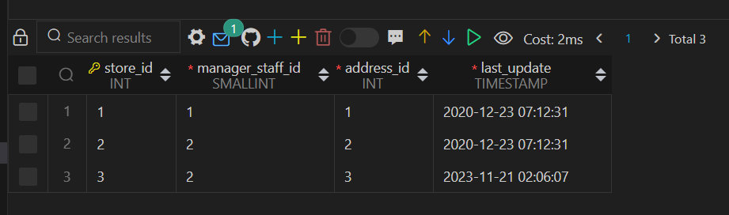

*Got an error, but seemed to work*

6.

INSERT INTO customer (customer_id, store_id, first_name, last_name, email, address_id, active, create_date, last_update)

VALUES

(603, 3, 'Tim', 'Tom', '@nyemail', 603, 1, TIME(), TIME()),

(604, 3, 'Bill', 'Bob','@nyemail', 604, 1, TIME(), TIME()),

(605, 3, 'Jill', 'Jones', '@nyemail', 605, 1, TIME(), TIME())

7.

SELECT customer.*, staff.first_name AS manager_first_name, staff.last_name AS manager_last_name

FROM customer

JOIN staff ON customer.store_id = staff.store_id

WHERE customer.store_id = 3;